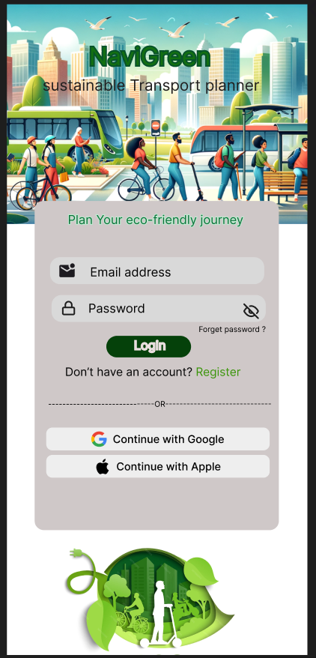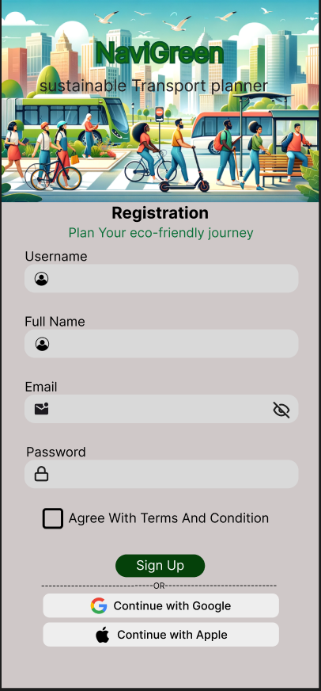
This section represents the login and registration pages for our eco-friendly journey application. The login page allows existing users to access their accounts by entering their username and password or by using Google or Apple sign in. The registration page enables new users to create an account by providing their username, email, password and agreeing to the terms and conditions before signing up.

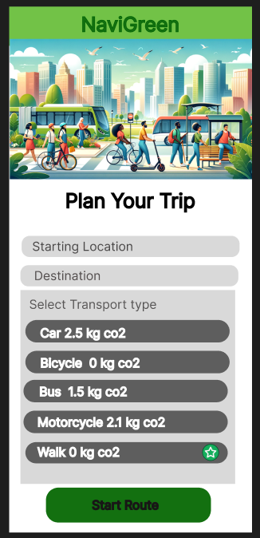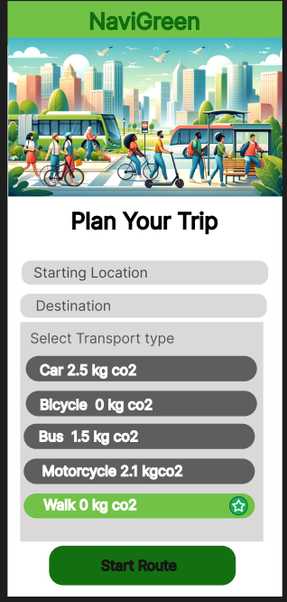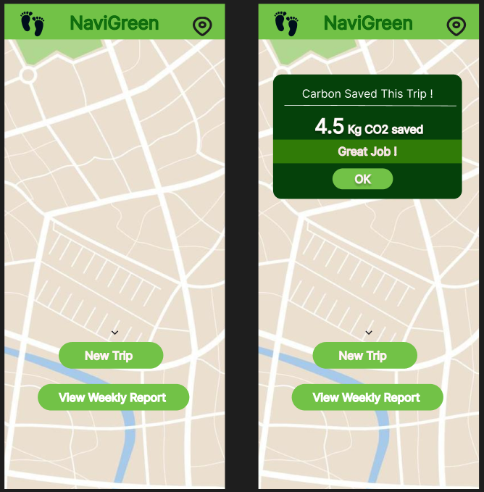
NaviGreen is a mobile application aimed at promoting environmental conscious travel. The app allows users to plan trips by entering their starting point and destination. After entering the destination, the app will suggest an optimal route for the users. A key feature of NaviGreen is its ability to calculate the estimated carbon savings achieved for each trip, it expresses in kilograms of CO2 avoided. In addition, the app complies weekly reports summarising total carbon savings, enabling users to monitor and reflect on their travel impact. This functionality supports sustainable transport choices and encourages users to reduce their overall carbon footprint.
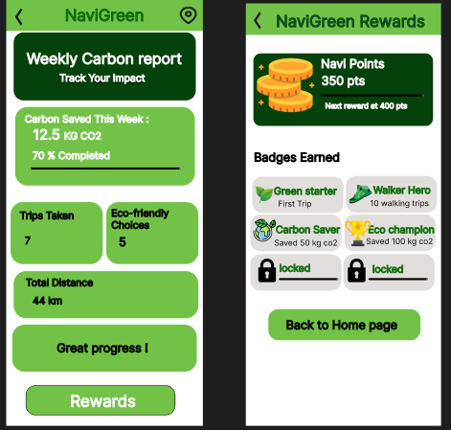
NaviGreen is a sustainability tracking app that monitors users weekly carbon impact based on their travel activity. It calculates total distance travelled, estimates the carbon footprint and rewards users with eco-points and badges for environmentally friendly habits. These points can then be redeemed for rewards that encourages users to reduce emissions and engage in greener pratices.

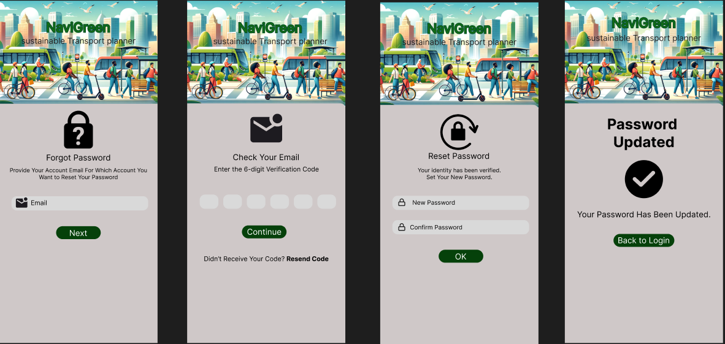

The forgot password feature in the NaviGreen application is designed to help users recover access to their accounts if they forget their login password. This process ensures that the user's identity is verified before allowing them to reset their password, improving account security.
First, the user selects the Forgot Password option and enters their registered email address. The system will then send a 6-digit verification code to the user’s email. This step ensures that only the owner of the registered email can proceed with the password recovery process.
Next, the user must check their email and enter the verification code in the application. If the code is correct, the system confirms the user’s identity and allows them to continue to the next step. If the user does not receive the code, they have the option to request a resend code.
After the verification is successful, the user will be directed to the Reset Password page where they must enter a new password and confirm it. This ensures the password entered is correct and reduces errors.
Finally, once the new password is successfully updated, the system displays a Password Updated confirmation message. The user can then return to the login page and access their account using the new password.
This process improves the security, usability, and reliability of the NaviGreen application by ensuring that password recovery is both safe and easy for users.

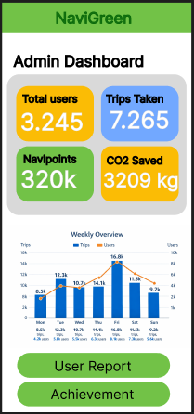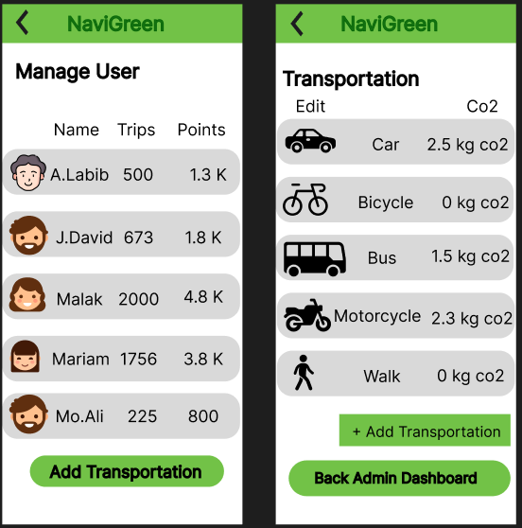
The NaviGreen admin interface allows administrators to monitor system performance, manage users, and control transportation data. The Admin Dashboard provides an overview of key statistics such as total users, trips taken, Navipoints earned, and the amount of CO₂ saved through sustainable transportation. It also includes a weekly chart to help administrators analyze user activity and system performance.

